This document shows how to install and configure the Data Direct Oracle Wire driver on Windows 32 bit OS. Invoke the 32-bit Microsoft ODBC Administrator to create a DSN (system or file) using tnsnames entry and then connect to Powebuilder using ODBC connection. The same steps can be followed for 64 bit.

**Version**

|  |  |
| --- | --- |
| **Product** | **Version** |
| **Data Direct Oracle Wire** | **DataDirect 8.0 (v8.00.02.2091 Oracle Wire Protocol)** |
| **Powerbuilder** | **2017 R3 Build 1858** |
| **Oracle Instant Client** | **32 bit – 18.5.0.0.0** |

**STEPS**

1. **Download Oracle instant client**

You should use the latest version of the client that Oracle supports against your database server.

1. Download instant client from the following link:

<https://www.oracle.com/technetwork/database/database-technologies/instant-client/downloads/index.html>

I have downloaded Windows 32 bit package.

It will navigate you to the download page.

Accept the License and download basic package.

Unzip the file in a folder. I have created a folder called oracle in my C drive and then

have unzipped the instant client there.

1. Set the environment variable

Now edit the path in your environment.

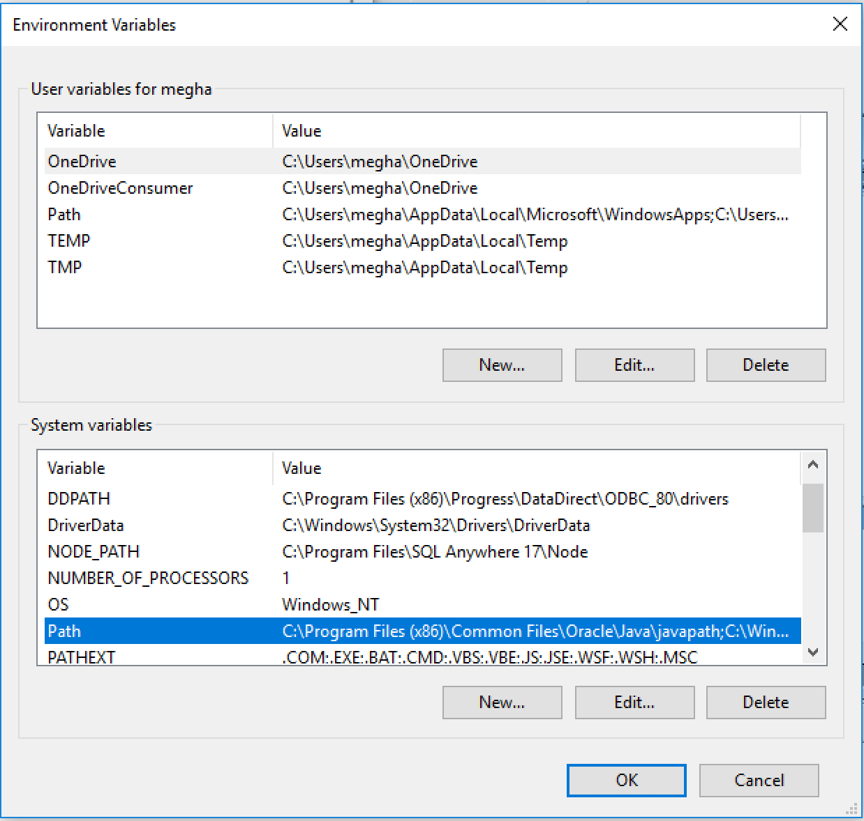

Add the following path: **C:\oracle\instantclient_18_5**

1. **Download Autonomous Database Wallet :**
2. Download the credentials file from the ADW administration console and unzip the file.

I have copy pasted all the file in a folder called “admin” inside “network” which is inside instantclient_18_5 (I have created the network and admin folder). The location of this files directory will now be referred to as the ‘wallet_directory’. Oracle credentials file is a zipped file that contains all the wallet formats as well as a predefined tnsnames.ora and sqlnet.ora that will be required to make a tnsnames based connection. This credentials file is protected by a password based encryption. You will use this password later on during the driver configuration. It will be referred to as KeyStore/TrustStore password.

1. Navigate to your directory and open sqlnet file. Change the following parameter:

**DIRECTORY=<<The full wallet_directory path>>**

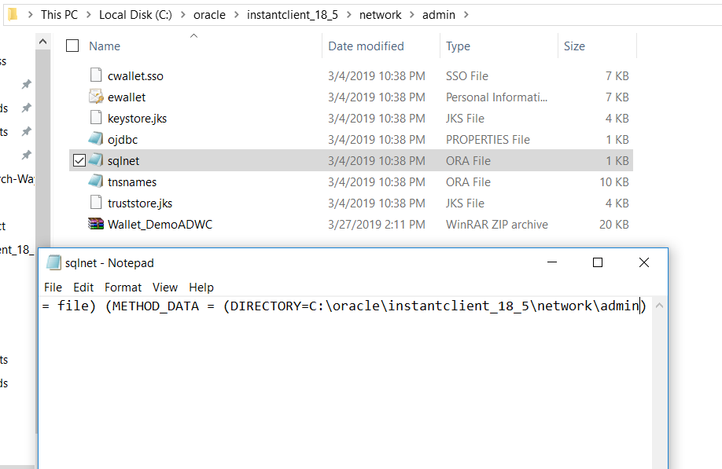

1. Add a system variable.

Click on new in system variable, and add TNS_ADMIN as variable with value as wallet_location

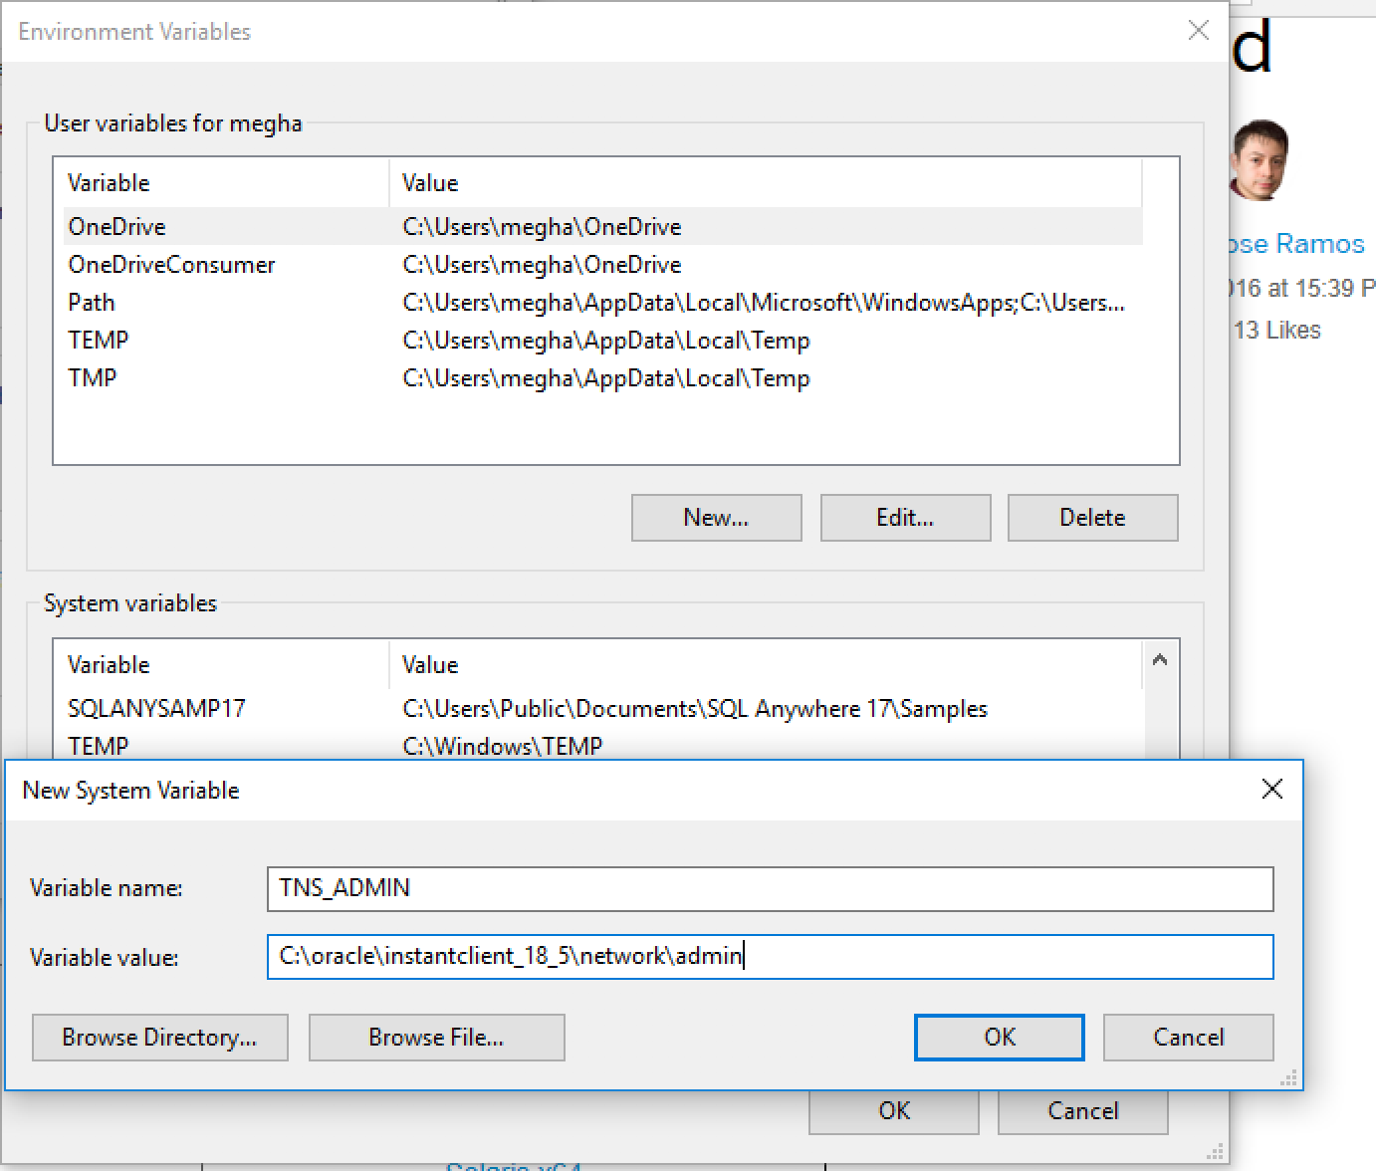

1. **Download Progress DataDirect’s ODBC Driver for Oracle and configure**.
2. Download it from here: <https://www.progress.com/odbc/oracle-database>

I have downloaded for Windows 32-bit.

1. Unzip the file and run the Application.

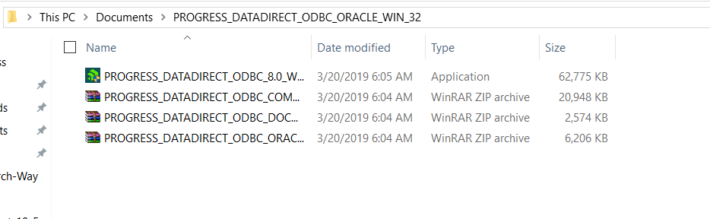

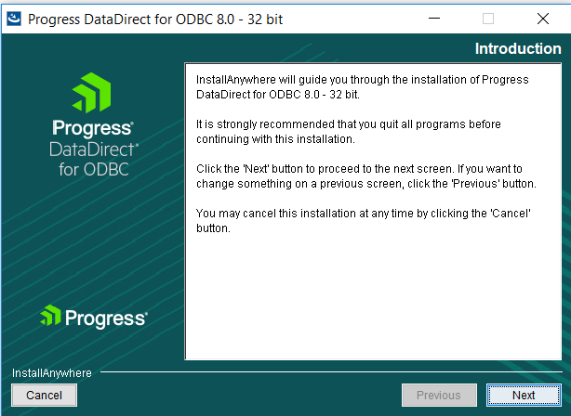

Click on next till you reach the following page:

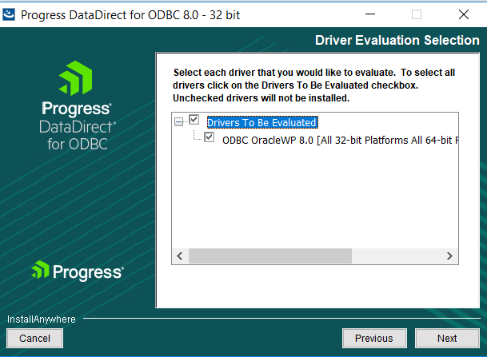

Here click on the arrow “Drivers To Be Evaluated”

Click on next

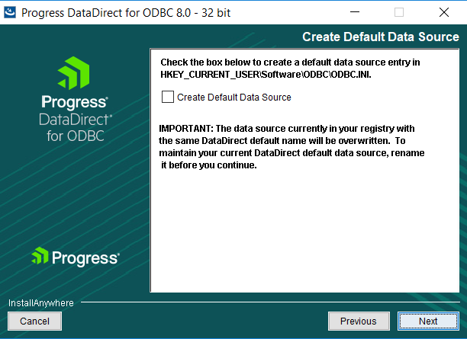

Leave this check box unchecked.

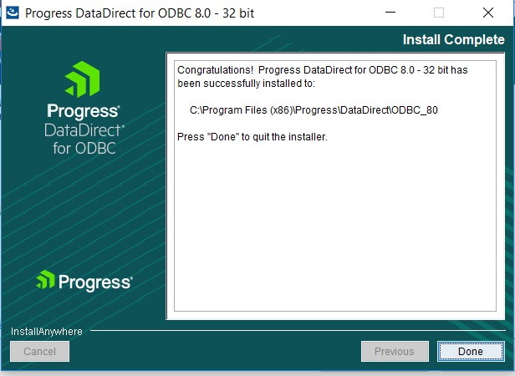

Click on done and the setup is finished.

1. **Invoke the 32-bit Microsoft ODBC Administrator to create a DSN (system or file) using tnsnames entry.**
2. Open “ODBC Data Source Administrator (32-bit), and click on “System DSN”.

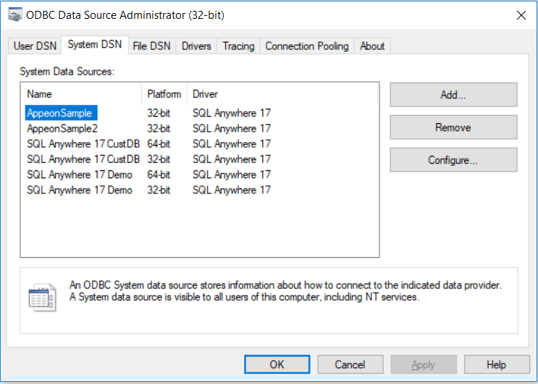

1. Now click on “Add” and select “DataDirect 8.0 Oracle Wire Protocol”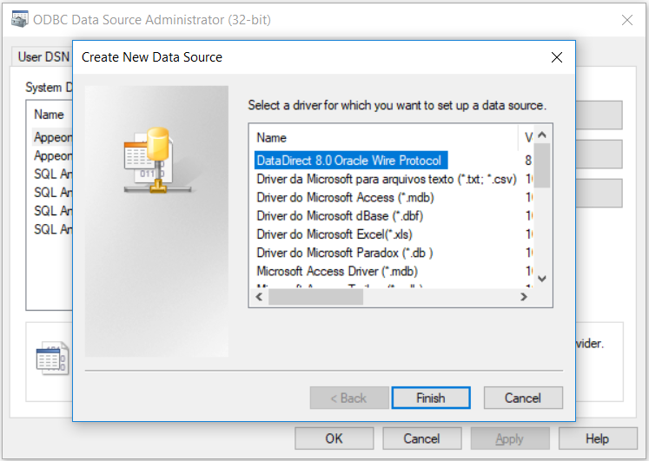
2. You will be presented with a form for the DSN attributes. Fill in the DSN name, your TNS service name (this can be found in the tnsnames.ora file in TNS_ADMIN location) and complete path to the tnsnames.ora (\tnsnames.ora)

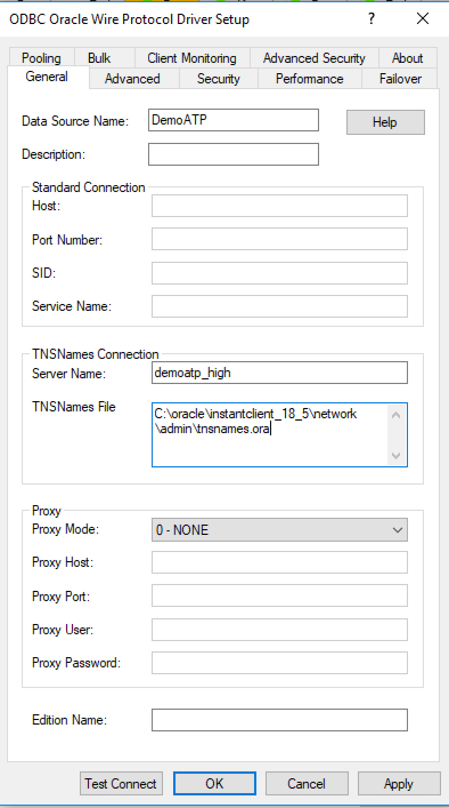

1. Next click on the Security tab and choose Encryption Method to be 1-SSL in the Encryption section. Also supply the path and name of the wallet to be used. Data Direct prefers the ewallet.p12 wallet file. The path should be \ewallet.p12. Supply this information for both the Trust Store as well as the Key Store sections. The password to be supplied here is the KeyStore/TrustStore password. You may optionally supply the Database username in the Authentication section.

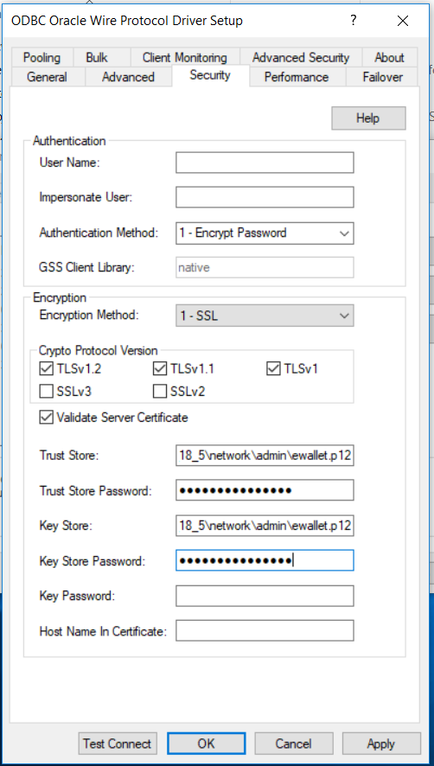

1. Test your connection by pressing the Test Connect button. Supply the database username and password to test the connection

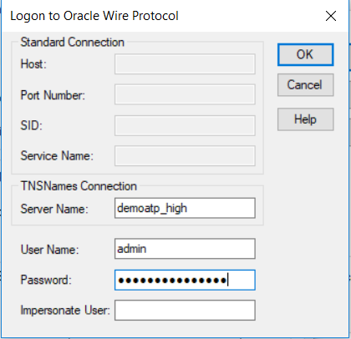

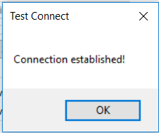

You are now ready to use this system DSN for your application!

1. **Download powerbuilder**

Click on the link to download powerbuilder:

[http://file.appeon.com/download/APB/2017/R3/GA/build_1858.00/PWRBLDR-2017R3LTS-1858-UNV-EN.zip](https://urldefense.proofpoint.com/v2/url?u=http-3A__file.appeon.com_download_APB_2017_R3_GA_build-5F1858.00_PWRBLDR-2D2017R3LTS-2D1858-2DUNV-2DEN.zip&d=DwMDaQ&c=RoP1YumCXCgaWHvlZYR8PZh8Bv7qIrMUB65eapI_JnE&r=rDWMD2DfcWFkzfQyetdgmRBi7D6wfA31NZGGZDMqcrk&m=Ndhp5NN0LemZI4hU1OJAZ-2Rr4eZiJqAccXXeL50OEw&s=9ALduiEWEB3FX7Q2INASF51WGkpLK5rXesiRtHPdLBY&e=)

Once it’s downloaded, unzip it and click on “Autorun” application

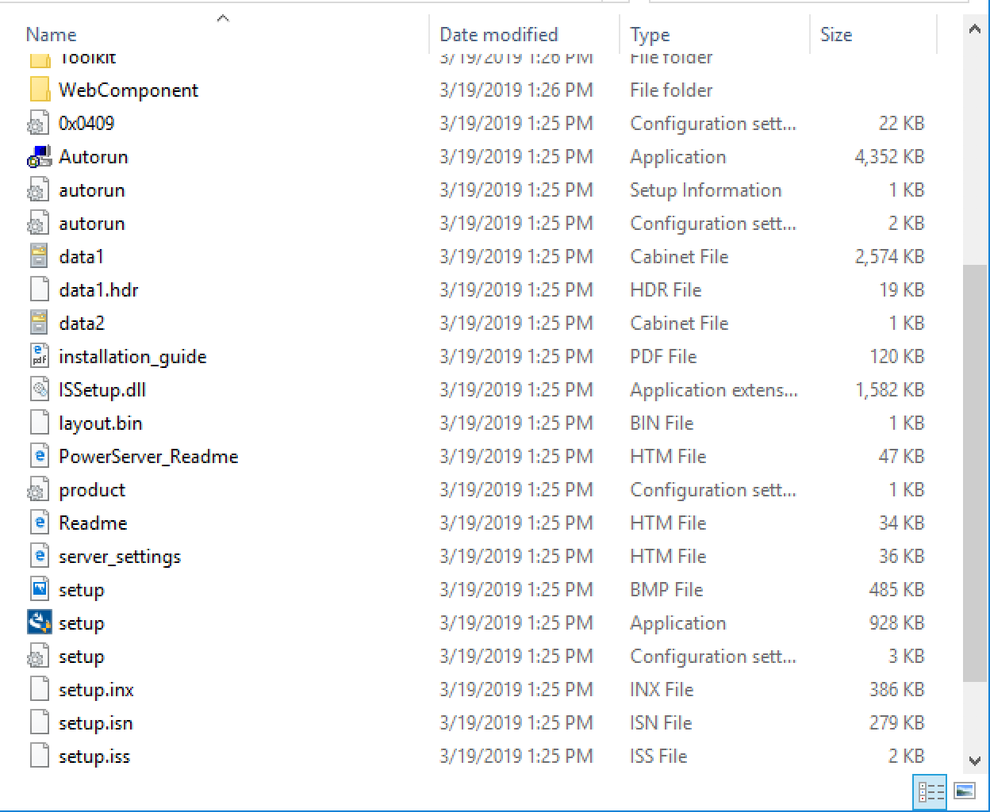

After the setup is completed, open powerbuilder.

1. **Create ODBC connection from Powerbuilder to Autonomous Database**
2. Click on “Database”

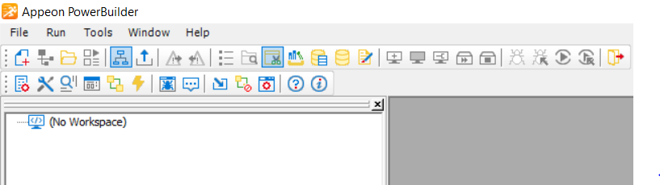

1. Right click on ODB ODBC connection and click on “New Profile”.

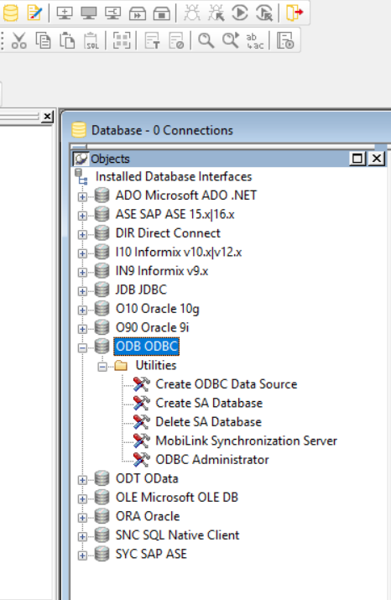

1. Give a profile name. Select “Data Source” as the ODBC connection that you just created. You will see it in dropdown. Give your user ID as your Autonomous User. I am using “admin” and then give your database password.

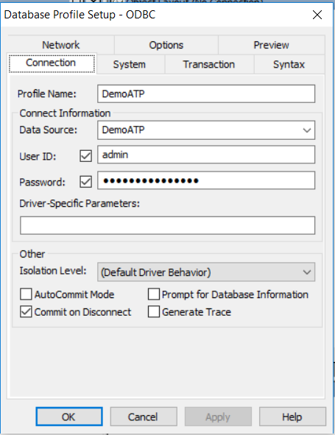

Click on OK.

Your autonomous database is now connected to Powerbuilder and you can see all the tables.

